**Talend Cloud Management Console**

**Installation Guide & Documentation**

Approval

| Signatures by each signatory indicate their acceptance that this document is complete and accurate to the best of his/her knowledge per responsibilities outlined in this document and as guided by approved methodologies and established procedures. | | |
| --- | --- | --- |
| Talend Lead:  Artha Emp | **Subhransu** | **Date:** |
| Project Manager:  Artha Emp | **Pavan Valluri** | **Date:** |
| Talend Developer:  Artha Emp | **Omkar** | **Date:** |

**Talend Cloud Management console**

**1)Operations**

*Check the history of all the jobs.

*Give the detailed view of All, Running, Failed, Successful, Terminated, Rejected jobs.

*We can check the jobs by filtering different Environments, Time period, Workspaces and different type.

* The Operations section allows you to monitor the status and progress of Talend Data Integration jobs in real-time. You can view information such as job execution logs, statistics, and error messages, which helps in troubleshooting and performance tuning.

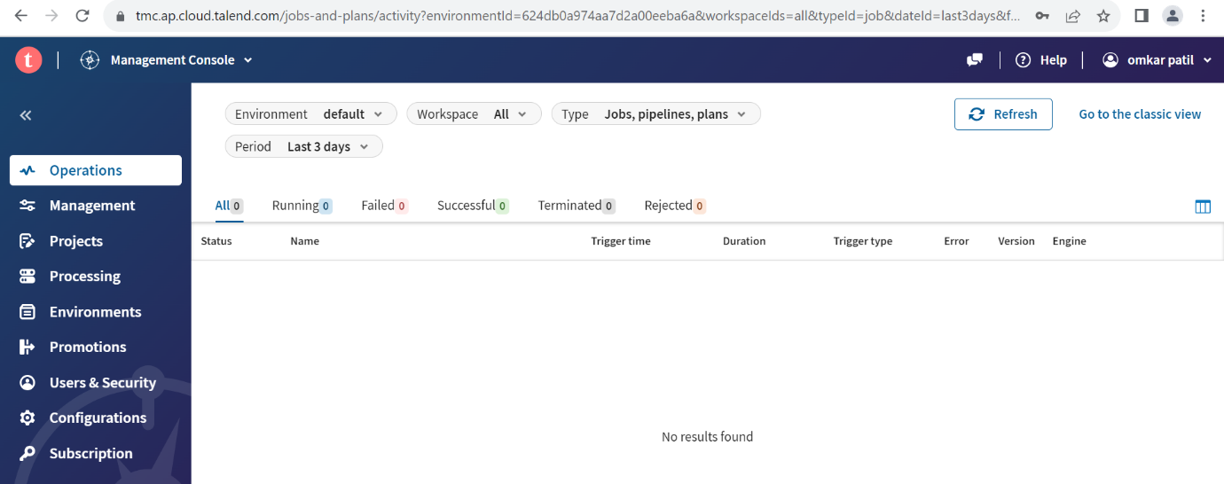

**2)Management**

*All the published jobs will be store in management.

*we can publish the jobs in different workspaces and Env.

a) Workspace

1. We can deploy jobs in required in Workspace.
2. We can create multiple Workspace in one Env.
3. Deploy jobs in Required Environment.

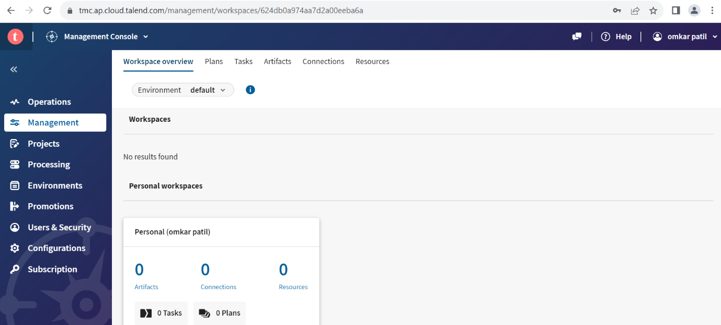

b) Plan

1. We can create plan with different tasks.
2. Add a plan and run the all the tasks parallel.
3. Run the different tasks and Run it parallel.
4. Create, pause, trigger, and delete the plans.
5. Schedule required jobs by using plan.

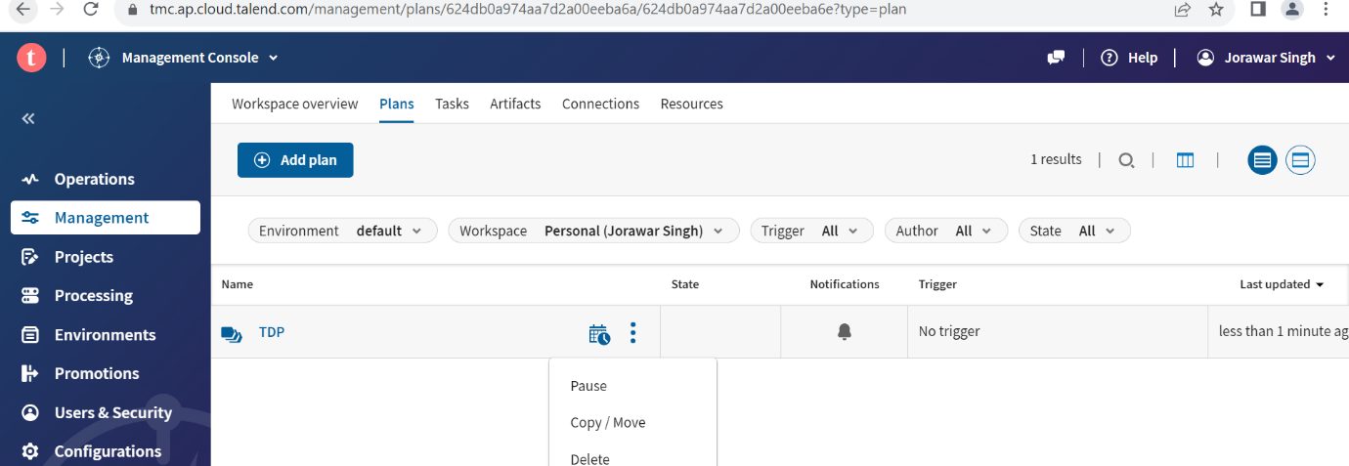

C) Task

1. After publishing the job to cloud create the automatically create the artifact.
2. Create the task based on Artifact.
3. Add the task based on different versions, tags and, parameters.
4. Add the engine to run the job.
5. By creating the task, we can run the job.

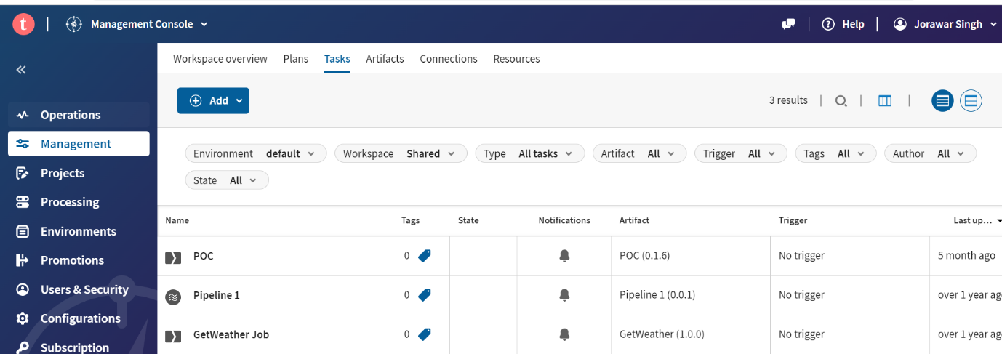

D) Artifact

1. After publishing the job to cloud it will create the Artifact.
2. Publish jobs on different environment.
3. Filter the jobs based on Env, workspace and Type.

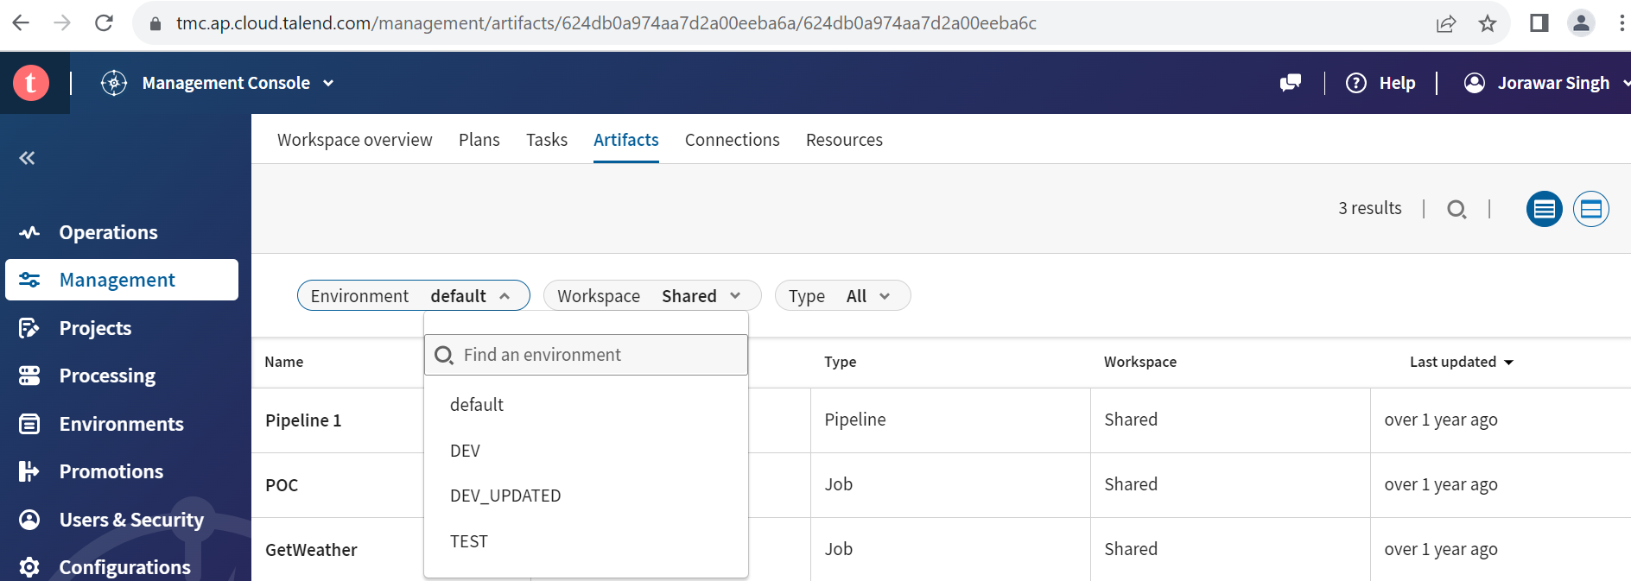

E) Connections

1. Add the connection depend on job.
2. If publishing the MySQL database credentials in job. We have to add the database credentials in connections.
3. Add the different context parameters of Studio job in connections.
4. While creating the task add the connections, and run the job.

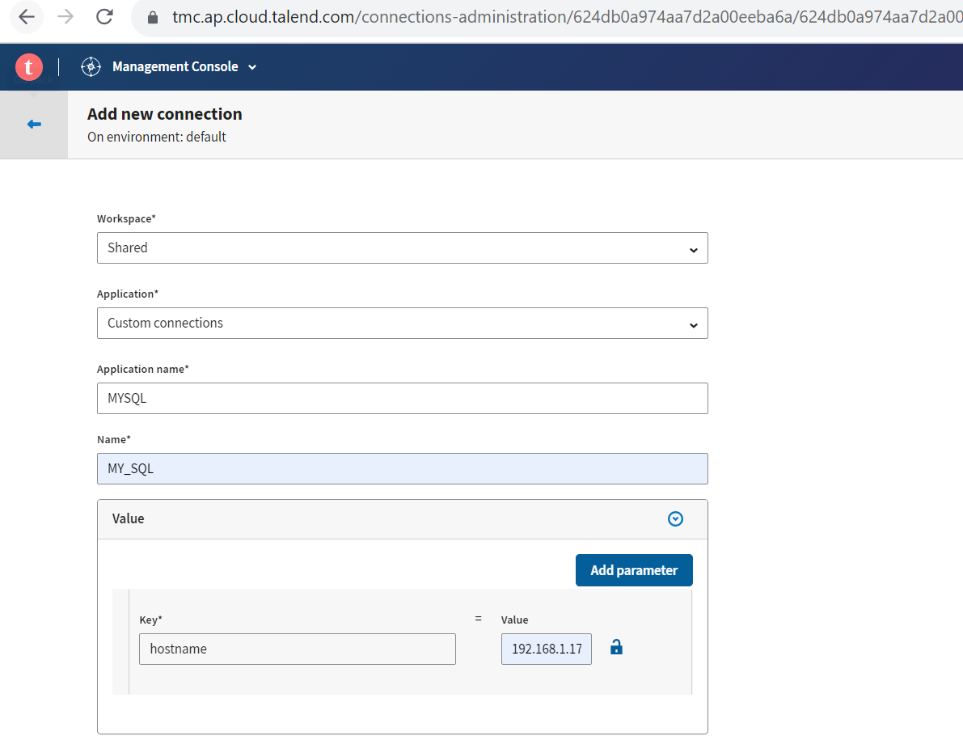

F) Resources

1. Talend Cloud Management Console can be used as a cloud data source to store files and directories to use within your task, just as Talend Studio artifacts can interact with resources from your file system
2. Add the resources while creating the task.
3. The resource size limit per file is 100Mib with a 5% tolerance.
4. Total size of resources per account is 10GiB.
5. Directories are imported as .zip archive

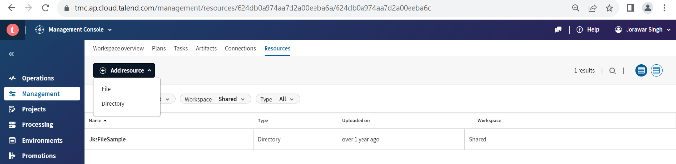

**3) Project**

* Projects are only visible in Talend Studio if you assign users to them in Talend Cloud Management Console.

* Users assigned to the project can now access it from Talend Studio.

* On the **Info** tab of a particular project you can modify the Git project URL, the owner, and the description of the project.

*Add the git credentials for creating the project.

* We can share the project to different user.

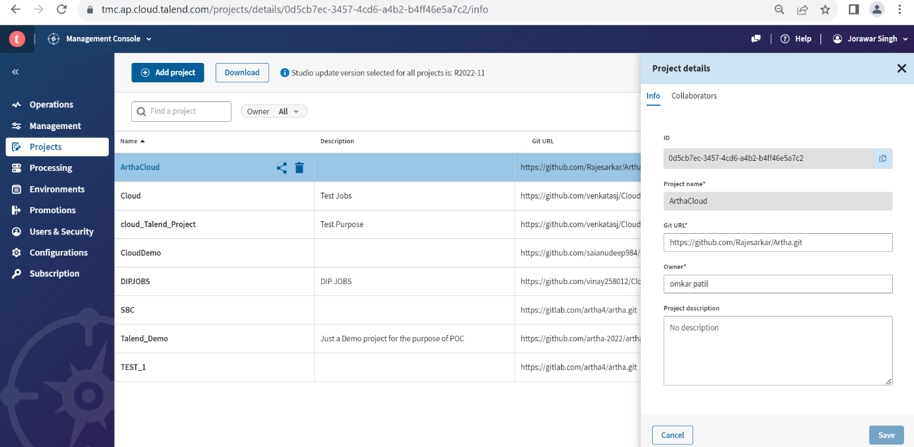

**4) Processing**

*Add the Remote engines to run the job.

*Create the Different Environments and install or Run the engines as per requirement based on Env.

# * **Cloud Engine, Remote Engine, Remote Engine Gen2.**

|  |  |  |
| --- | --- | --- |
| **Cloud Engine (CE)** | **Remote Engine (RE)** | **Remote Engine Gen 2 (REG2)** |
| Cloud Engines allow you to run batch tasks that use on-premises or cloud applications and datasets (sources, targets) | Remote Engines allow you to run batch tasks or microservices (APIs or Routes) that use on-premises or cloud applications and datasets (sources, targets) | The Remote Engine Gen2 is used to run artifacts, tasks, preparations, and pipelines in the cloud, as well as creating connections and fetching data samples |
| Consumes 45,000 engine tokens | Consumes 9,000 engine tokens | Consumes 9,000 engine tokens |
| No download required - Runs within Talend Cloud platform | Downloadable software from Talend Cloud platform | Downloadable software from Talend Cloud platform |
| Managed by Talend, run on-demand as needed to execute Jobs | Managed by the customer | Managed by the customer |
| No customer resources required | Can run on Windows, Linux, or OS X | Require compatible Docker and Docker compose versions for Linux, Mac, and Windows |
| Set physical specifications (Memory, CPU, and Temp Disk Space) | Unlimited Memory, CPU, and Temp Space | Unlimited Memory, CPU, and Temp Space |
| Require data sources/targets to be visible through the internet to the Cloud Engine | Hybrid cloud or on-premises data sources | Hybrid cloud or on-premises data sources |
| Restricted to three concurrent Jobs | Unlimited concurrent Jobs (default three) | Unlimited concurrent pipelines (configurable) |
| Available within Talend Cloud portal | Available in AWS and Azure Marketplace | Available as an AMI Cloud Formation Template (for AWS) and Azure Image (for Azure) |
| Runs natively within Talend Cloud iPaaS infrastructure | Uses HTTPS calls to Talend Cloud service to get configuration information and Job definition and schedules | Uses HTTPS calls to Talend Cloud service to get configuration information and pipeline definition and schedules |

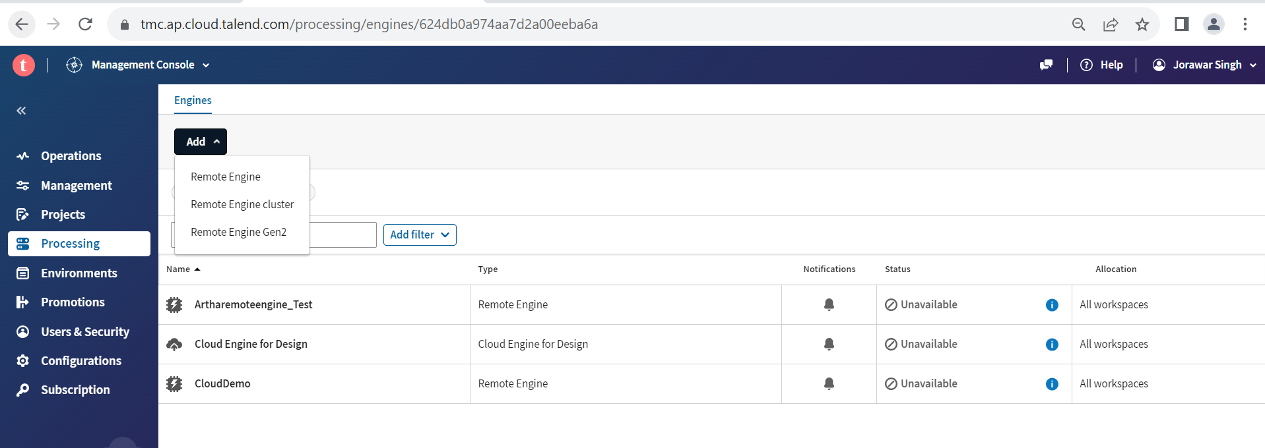

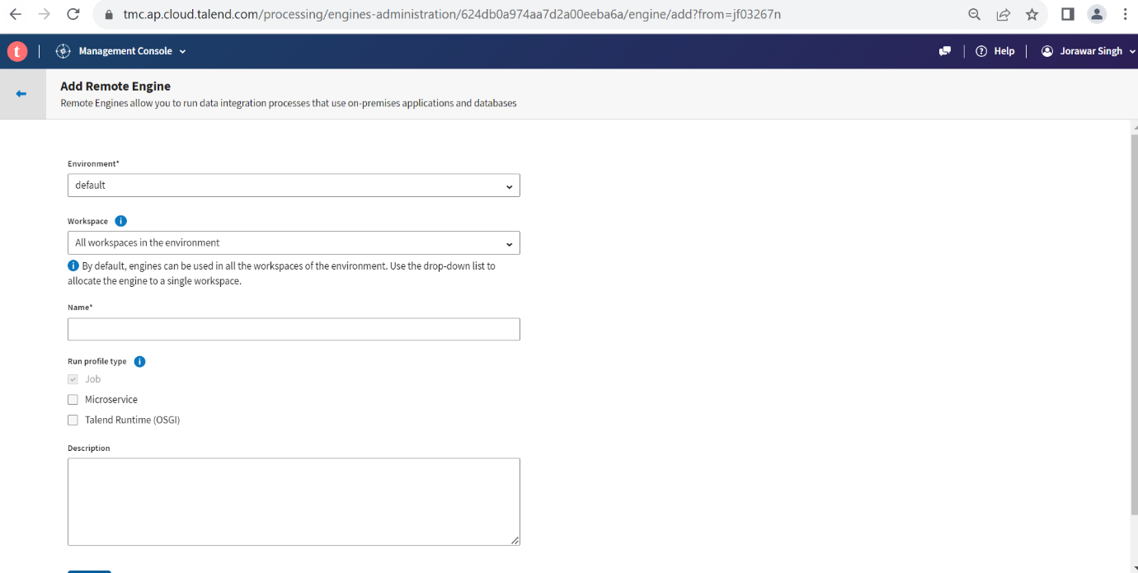

**5) Environment**

*Add the different Environment as per the project flow.

Ex: - DEV, TEST, PRE-PROD, PROD

*Create the workspace in the Environment.

*We can add multiple Workspace in the same Environment.

*Give the users permissions to the Workspaces.

*The environment is created with the workspace you specified.

*An environment is a self-contained space with the required resources (connections, engines, and so on) that allow the execution of tasks and plans in isolation, with no impacts on other environments.

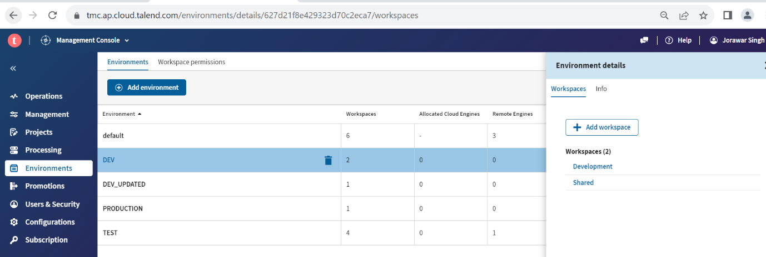

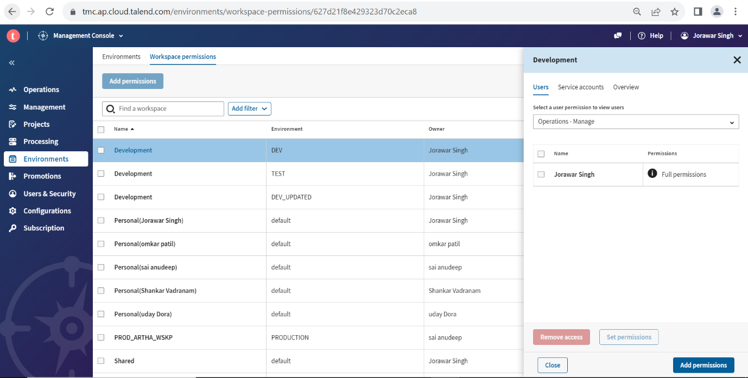

**6) Promotions**

*You can promote all the artifacts and workspaces of an environment at once. To preserve ownership and control of environments, we recommend that the promotion is executed by the owner of the target environment.

*We can transfer all the jobs from one environment to another environment.

*You must be assigned to the promotion.

*Ensure that no other promotion is running at the same time on the same source and target environments.

*You must have access to at least one workspace in the target environment.

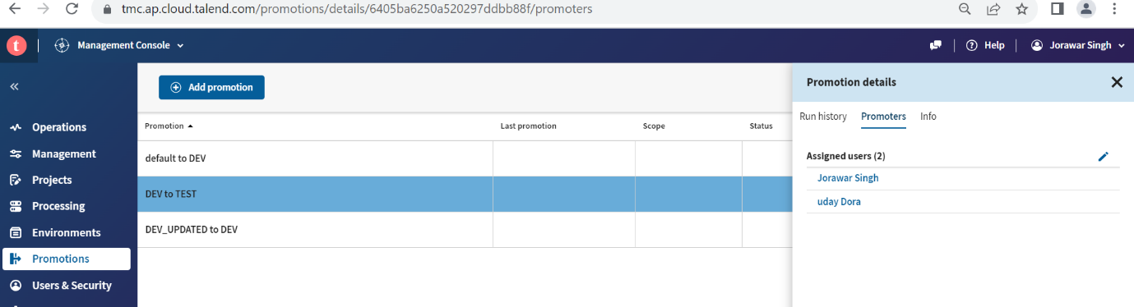

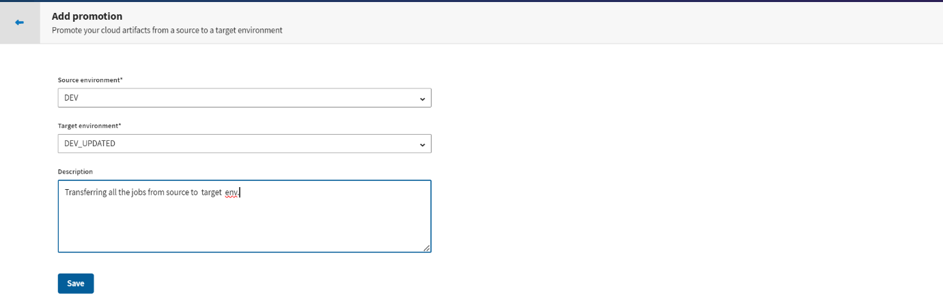

**7) Users & Security**

*In the **Users** tab, you can create and delete individual users, add them to user groups and assign them preconfigured roles for each application, as well as update the password policy.

*In the **Roles** tab, you can create or delete user roles, manage their permissions, and assign them to users.

*In the **Groups** tab, you can create or delete user groups and add users to them.

*The new user appears in the list of users. Talend Cloud Management Console sends an invitation email to the user to join and create a password. The user details and the assigned roles and groups can be edited directly from the **Users** tab.

*Deactivated users can no longer log in to Talend Cloud and cannot use their personal tokens.

*Deleting users

When an user account is deleted, changes happen to the tasks, plans and remote engines related to this account.

1. **Personal** workspaces: anything in the **Personal** workspace of the deleted user account is removed, as this workspace is automatically removed with this account.
2. **Custom** workspaces: a **Custom** workspace to which the deleted user account was assigned as owner remains; so the objects in this workspace are still available.
3. **Shared** workspace: this workspace, as well as the objects in it, remains.
4. Remote Engines: a Remote Engine remains. If this engine was assigned to the personal workspace of the deleted user account, it is automatically unassigned from that personal workspace.

*Export the list of users to a CSV file to build reports in external tools. You can export all columns and data for all users or a specific user.

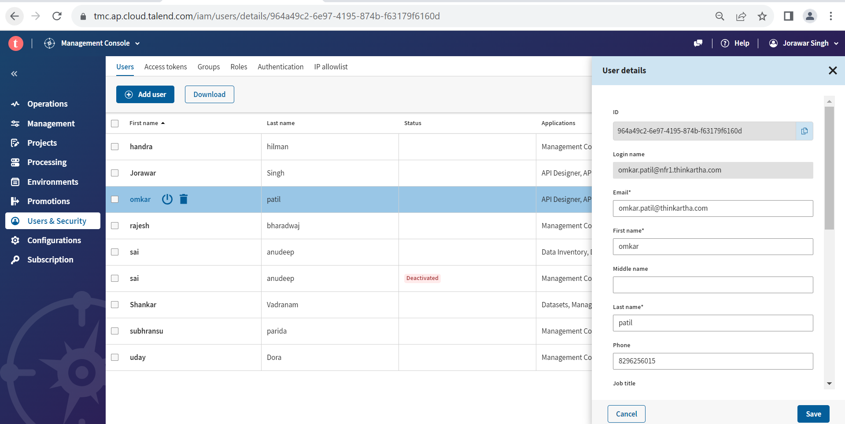

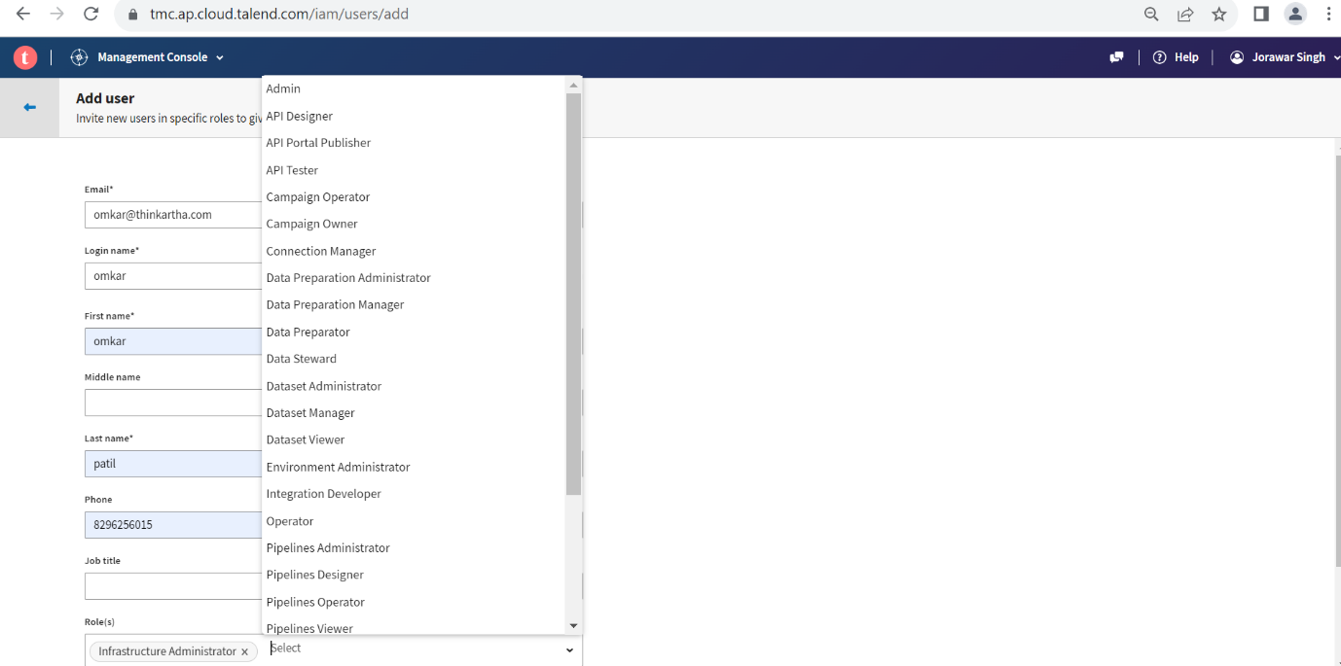

**8) Configuration**

**\***In Hybrid Installation of Talend Data stewardship and Talend Data preparation we can generate the keys.

*Add the ip address of server save and generate the client ID & Client secret. Which required for Hybrid installations.

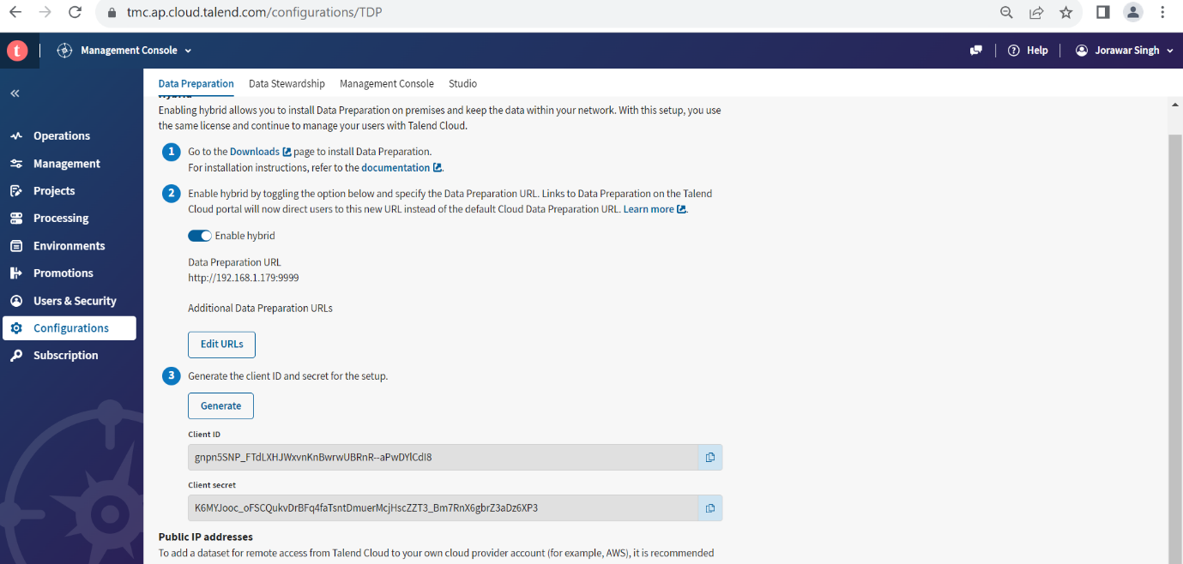

*In management console we can check all the static ip addresses of the server.

(Note: - which will allow to use the different Data sources ex- MYSQL database securely by configuring these ip’s in databases)

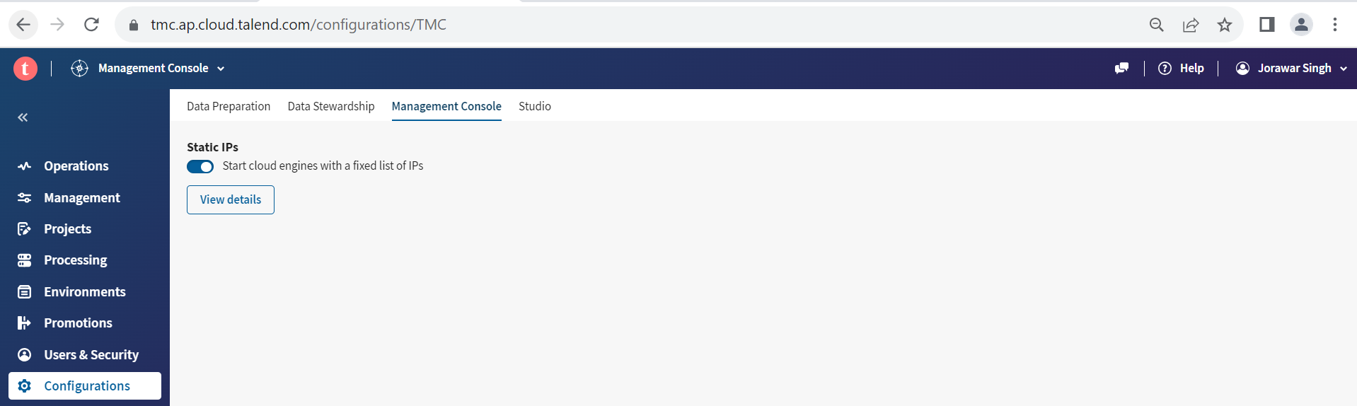

*In the studio we can check the updates of Talend Studio.

*We can configure the Artifact repository Nexus3.

*Apply the Available updates and check for updates.

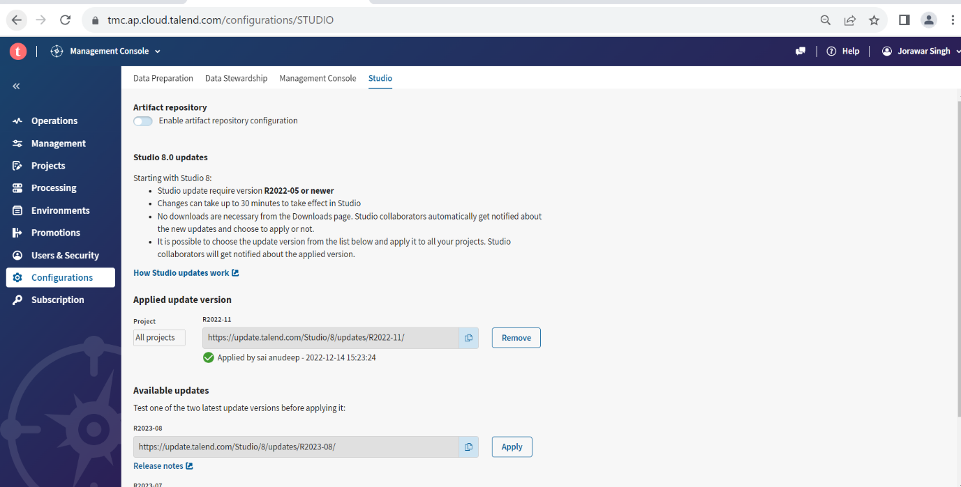

**9) Subscriptions**

**\***Check the number of services are provided by Talend Cloud for specific region.

*Check the number of tokens are used and number of tokens are available we can use the number tokens as provided.

*Check the seats allocations to the services.

Number of seats are available and number of seats are provided to the users.

*We can specific permissions to users as much seats available.

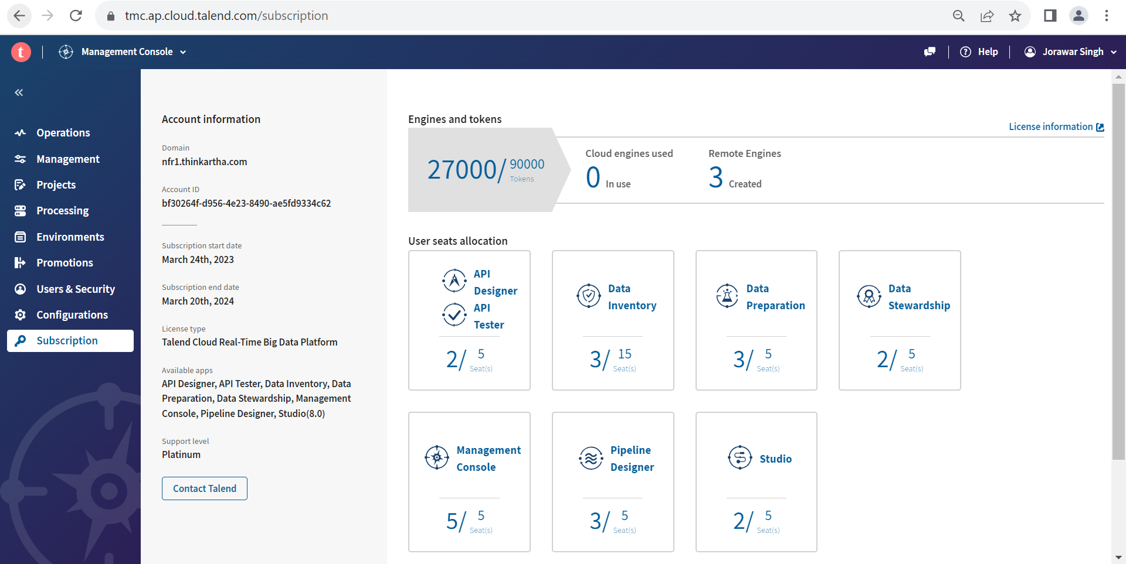

**10) Connecting Talend Cloud to Talend studio and publishing the sample job**

a) Generate personal Access token in the Talend Cloud.

1. Login name
2. Profile preferences
3. Personal Access token
4. Generate token
5. Copy and save the token

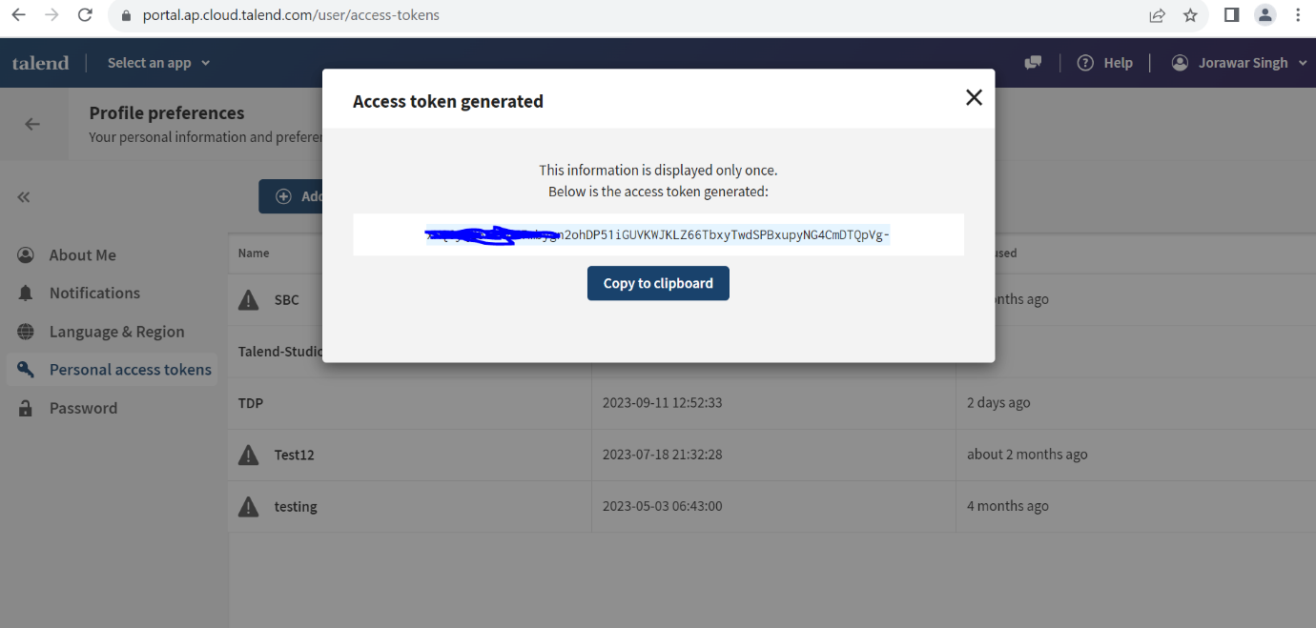

b) Create the project in Talend Cloud

1. Goto Talend Management console
2. Projects
3. Add project
4. Add the git url
5. Give the project name and owner name.
6. Give the users permission to the specific project in collaborators.

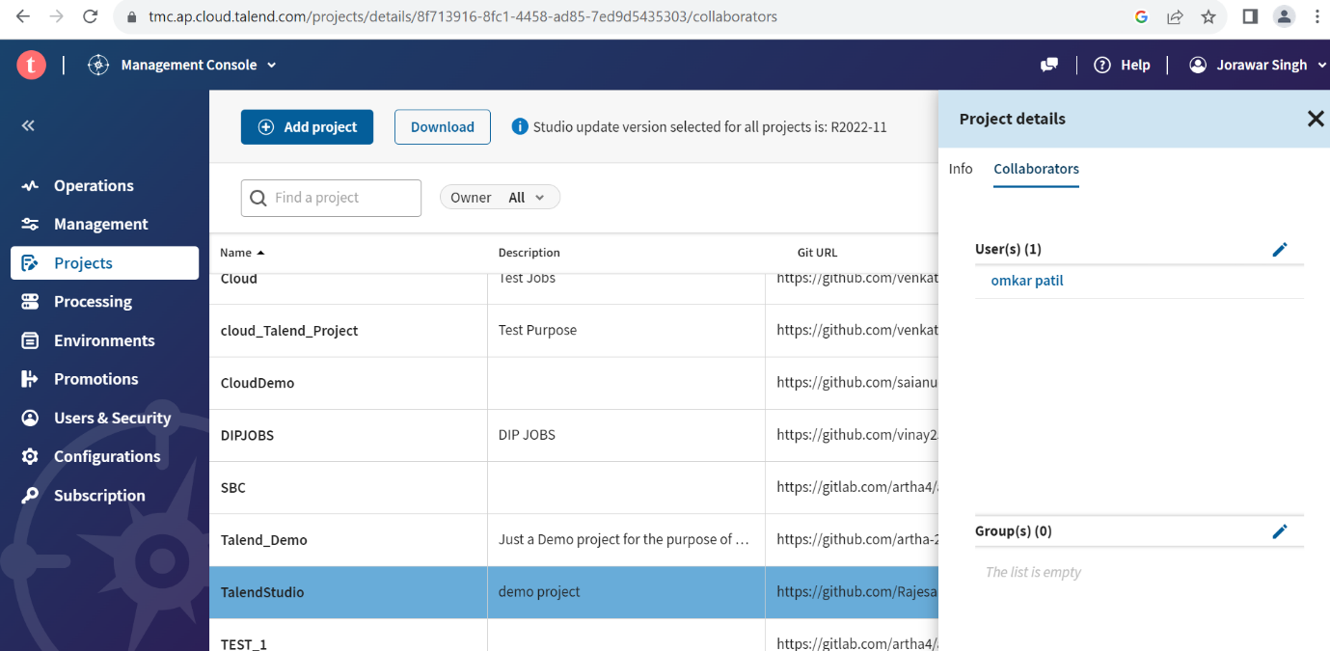

C) Open the Talend Studio

1. Other login mode
2. Click on edit button
3. Add the region and created personal Access token of cloud
4. Check the url
5. Click on the project
6. Create a demo project.
7. Upload to the Talend Cloud
8. Select the version and Workspace.

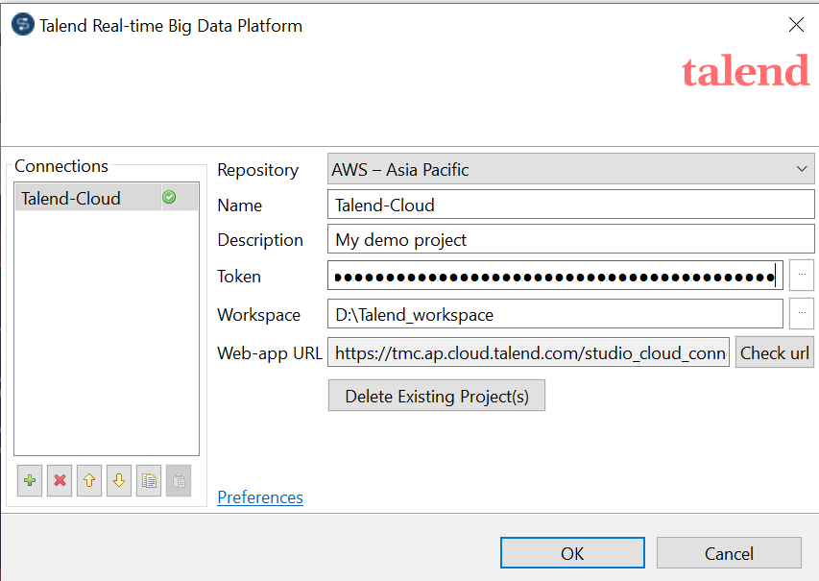

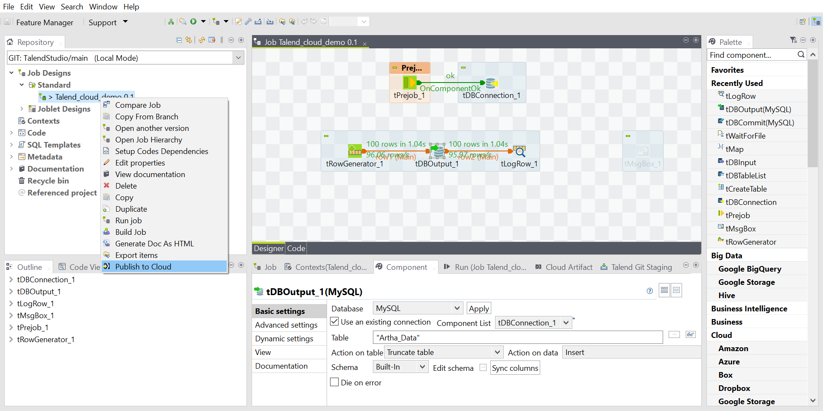

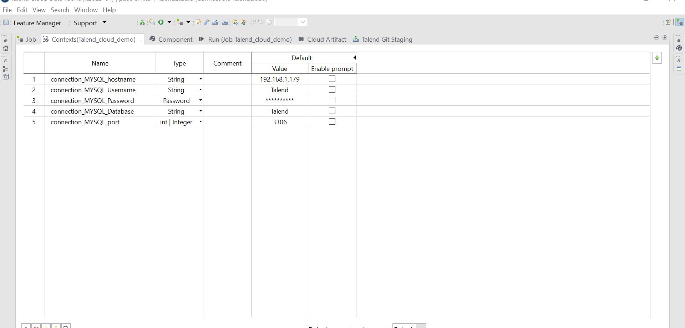

D) login to Talend Cloud (TMC)

1. Goto management console
2. Check Artifact has been uploaded
3. Create the task.
4. Schedule the job
5. Run the job.

(NOTE: - IF there any connections in Studio jobs create the same connections in TMC connections)

